BLACK KINGDOM MILLIONAIRE CREATIONISMS
Gig East Exchange-Downtown Wilson Historical Vollis Simpson’s Whirling Wringing
127 South Goldsboro Street Office Suite #110
Wilson, NC 27893

Black-Owned Business Brochure
April 11th, 2024

Overview
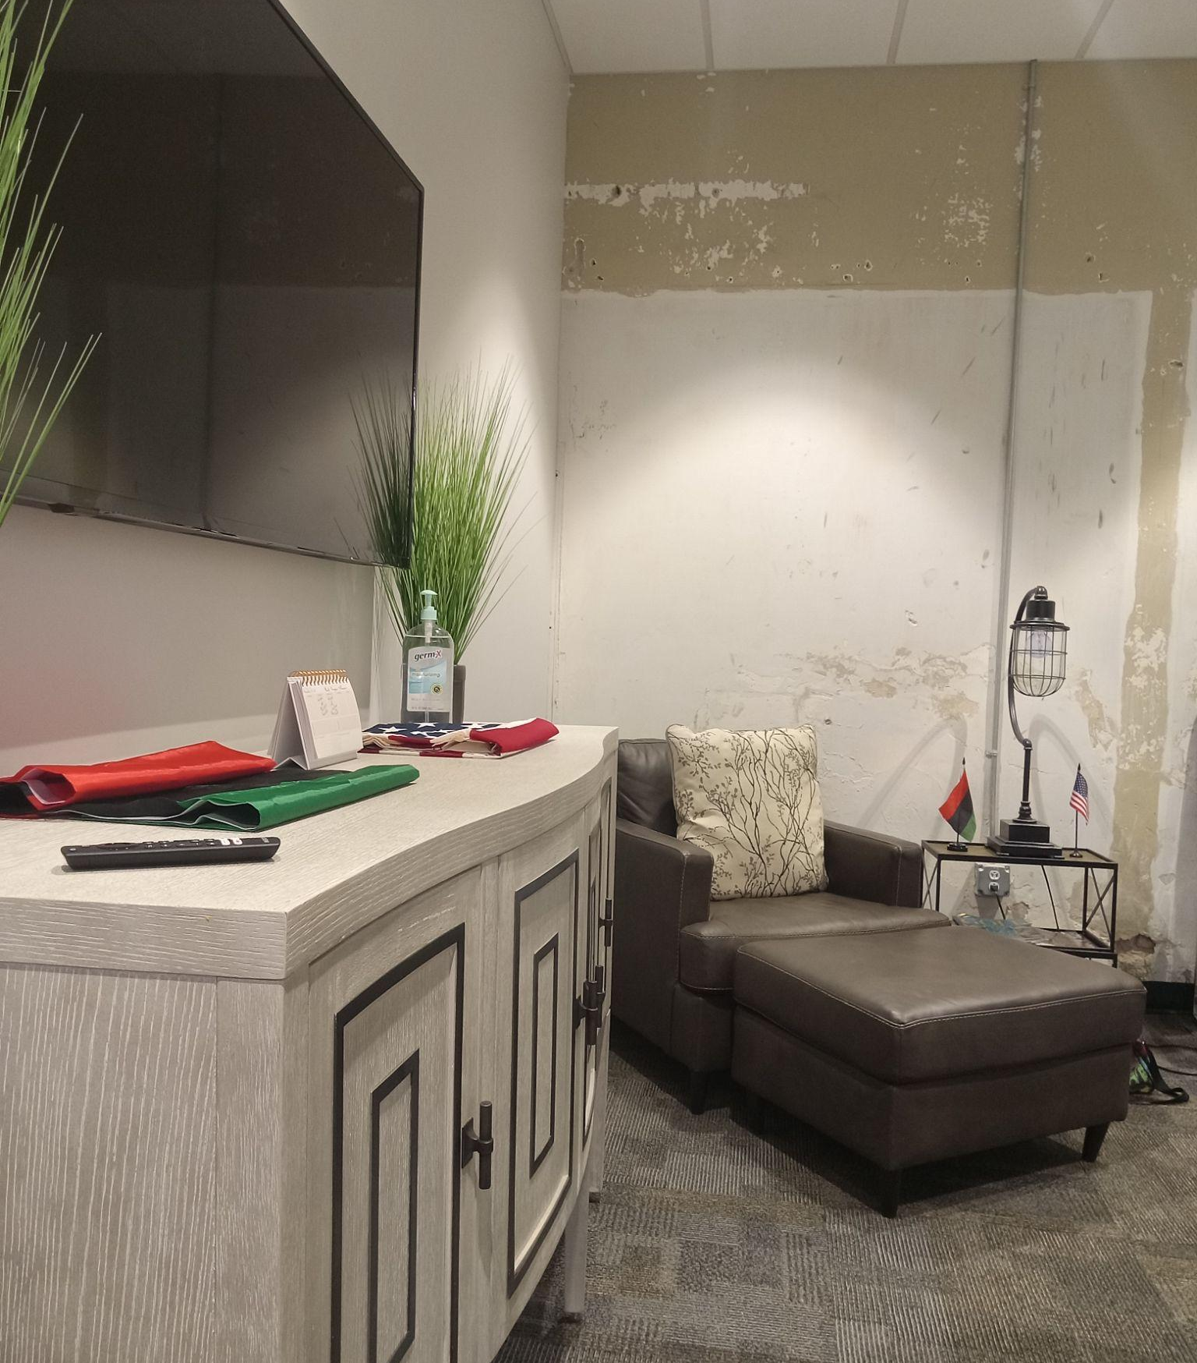
Black Kingdom Millionaire Creationisms would have a skill when the network creation does make more money for building your credit score, paying bills, doing a population growth of cashflow represent by MyEcon Network with a business worth multi-million dollars in each of year, creating a storyline and so on. I will help you with innovation to raise my community every time.

Skills
I will work for you on online purchases. Joining me now at MyEcon Independent Associate can improve the non-experience training required for your personality and the financial success of the company when I can be realistic in particular on time each of each year. Even though God will accept you for so many things he will have blessed you with everything.
Companies have a solution through this situation and condition with managing all the business of web development, accounting, and financial freedom in a professional method and rearranging the management for our digital marketing plans.

Details
Black-owned businesses should be the most difficult whether or not independent to start their own business without any doubt; however, the network skills are raised by the government's account. Companies will structure with the internet and intranet articles where your networking and accounting skills do most equally into combining the 24/7 per week training experience. An account of stock marketing will apply for Form W-4 on Personal Financial Success to perceive those identification records, protect your identity so that no one goes through the government's issues through all these amounts of money, eliminate the debt inside of co-workers spending much more money during a create their own business on the website, home improvement expenses, and so many more.
Since I was an Executive Vice President for personality financial success to reach out of agility, my goals conformed to becoming an Autistic with my disability; however, I had to work very hard on those 11 skills and write in reality network skills.
Becoming a Principal CEO should have been more difficult for me because I was in charge of the people's assessment jobs, which is my successful career future of a multi-million dollar style network.

“He Fills Up A Good Things From A Miracles” (Psalm 103:5)

